**CSE 207**

**DATA STRUCTURES AND ALGORITHM 2**

**SESSIONALS**



**OFFLINE NO : One**

**TITTLE : Report of Hash Table**

**SUBMITTED BY :**

**FAHMID - AL-RIFAT**

**STUDENT NO : 1705080**

LEVEL-2 ,TERM-2

DEPARTMENT OF CSE

BUET

**MACHINE CONFIGURATION:**

Code::Blocks 17.12

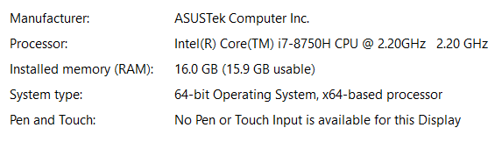

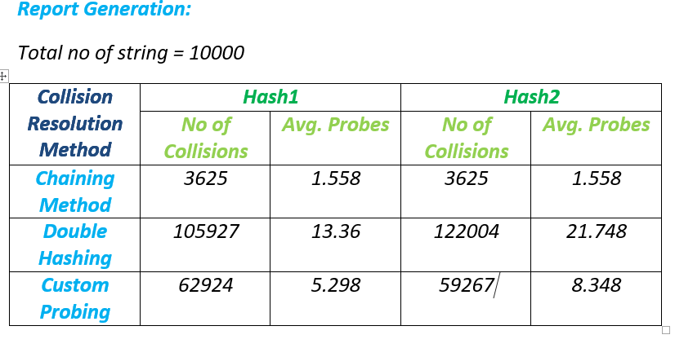

I